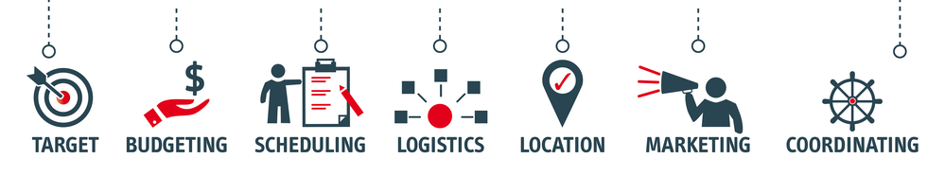
Minor in
EVENT, TOURISM & HOSPITALITY MANAGEMENT

Minor in Event, Tourism, & Hospitality Management

Program Description

The minor in event, tourism, and hospitality management is designed to provide students with a solid foundation in the principles and practices of managing events and tourism activities. This minor will equip students with the knowledge, skills, and practical experience necessary to thrive in this fast-paced and exciting industry.
The minor includes a wide range of courses that cover topics such as event design and planning, event marketing, event budgeting, risk management, sustainable tourism practices, and venue management. Students will also gain an understanding of the cultural, social, and economic impacts of tourism on local communities.
Students will learn how to plan and execute various types of events, including corporate and professional events, concerts and festivals, and sporting events such as competitions, tournaments, and multi-sport activities. Students will also gain insight into the role of event management in the broader tourism and hospitality industries.
Upon completion of the minor, students will be prepared to pursue careers in a variety of roles in the event, tourism, hospitality industry, including event planner, event coordinator, event marketer, tourism and hospitality manager, and guest experience manager.
Overall, the undergraduate minor in event, tourism, and hospitality management is ideal for students who are interested in the tourism, hospitality, and event industry and who want to develop the skills necessary to succeed in this exciting field.

Program Goals

- Build event planning and management skills: Students will learn how to plan, design, and execute a variety of events and experiences.

- Develop a foundational knowledge of the tourism and hospitality industry: Students will gain an understanding of the tourism and hospitality industry, including its history, structure, and trends.

- Enhance critical thinking and problem-solving skills: Students will learn how to analyze and evaluate the effectiveness of event, tourism, and hospitality management strategies, and how to develop innovative and practical solutions to complex problems.

- Develop professionalism and leadership skills: Students will develop the skills necessary to succeed in the event, tourism, hospitality industry, including effective communication, teamwork, and leadership.

- Engage in experiential learning: Students will have the opportunity to apply their knowledge and skills through internships, practicums, and hands-on projects, while having the opportunity to network with industry professionals.

Courses
The minor in event, tourism, and hospitality management requires 12 hours. Courses in the event, tourism, hospitality management minor include the following:

- MGT 248: Event Design and Execution
- MKT 248: Tourism Marketing and Promotion
- MGT 380: Event and Venue Management
Select one from below:
- SAM 448 Sports Promotions and Event Planning
- MGT 485: Sustainable Tourism Development
All students must complete ECN 101 Principles of Economics and MKT 200 Principles of Marketing as prerequisite general education electives to this minor.

Course Descriptions

MGT 248: Event Design and Execution: This course explores the principles and techniques of event design and execution. Students will learn how to plan and implement successful events, including festivals, conferences, and exhibitions. Topics covered include site selection, event marketing, event logistics, risk management, and evaluation.

MKT 248: Tourism Marketing and Promotion: This course examines the strategies and tactics used in tourism marketing and promotion. Students will study how to identify target markets, develop effective advertising campaigns, and use social media and other digital platforms to promote tourism destinations. Topics covered include destination branding, public relations, consumer behavior, and market research.
MGT 380: Event and Venue Management: This course provides a comprehensive overview of venue management and hospitality services within the context of events and tourism. Students will learn how to apply best practices for creating and managing memorable experiences for guests through effective customer service and engagement. This course covers venue selection, design, and management, including safety and security, logistics, and customer service.
SAM 448: Sports Promotions and Event Planning: This course provides a comprehensive look at what it takes to produce a successful event from conception to fruition to evaluation. In addition, this course covers the administration, promotion, and marketing of events while applying these concepts to the unique aspect of sports. This course provides a fresh perspective on event management. Upon completion of this course, students will understand the competencies necessary for managing and operating sport events through theory and application.

MGT 485: Sustainable Tourism Development: This course focuses on the principles and practices of sustainable tourism development. Students will learn how to balance economic, social, and environmental considerations when planning and managing tourism destinations. Topics covered include sustainable tourism planning, ecotourism, community-based tourism, and responsible tourism practices.

Programmatic Outcomes:

Students will develop the following outcomes:

- Knowledge and understanding of the principles and practices of event, tourism, hospitality management: Students will be able to demonstrate a deep understanding of the fundamental principles and practices of event, tourism, hospitality management, including the processes involved in planning, marketing, and delivering successful event and tourism experiences.

- Critical thinking and problem-solving skills: Students will be able to analyze event, tourism, hospitality management scenarios and apply critical thinking and problem-solving skills to identify and develop effective solutions. This includes the ability to identify and manage risks, create contingency plans, and make decisions that align with strategic goals and objectives.

- Communication and interpersonal skills: Students will have strong communication and interpersonal skills, which they will be able to apply in a range of event and tourism management contexts. This includes the ability to work effectively in teams, communicate with stakeholders, and negotiate and resolve conflicts.

- Ethical and sustainable tourism practices: Students will have a strong understanding of the ethical and sustainable practices that underpin responsible tourism and event management. They will be able to analyze the impacts of tourism and events on the environment, society, and culture, and develop strategies to minimize negative impacts and maximize positive outcomes.

- Professionalism and leadership: Students will have the skills and knowledge needed to excel in a range of professional roles within the event and tourism management industry. This includes the ability to lead teams, manage budgets, develop and implement marketing strategies, and deliver high-quality event and tourism experiences that meet the needs of customers and stakeholders.

